**Host Forensic Analysis**

**Grand Canyon University, College of Engineering & Technology**

**ITT-340**

**Professor Ingrid Gaviria**

**Liela Pressley**

**5/25/2024**

**Host Forensic Analysis**

Though the previously performed exploits were unable to be discovered in the host analysis as the attacks were performed on the VMs provided within LopesCloud, this assignment shows the steps that could be taken to find helpful logs in a true host analysis. By searching in the log folder as an admin you can see all of the different categories of logs that can be sifted through in order to find the changes or activity in the systems. For instance you would look for logs that are anomalies to your regular activity such as drastic amount of files opened, failed login attempts, ports being opened or have activity that don’t normally have activity or requested activity. These records would not be able to hold up in a legal proceeding as they do not reveal the characteristics, methodologies or technical details of the attack but if the following logs were from the attacks on the VM then they could withstand a legal proceeding. The logs not only provide a timestamp of the activity but also the detailed reports of steps that the attacker took.

By understanding the Cyber Kill Chain Methodology used by attackers, we can best understand what steps we need to look for in our analysis and what stages of attacks we need to be prepared for in our cybersecurity protocols. The diamond model is another great way to conceptualize the various angles cyber analysts can narrow their focus. The diamond model allows us to better understand the dynamics of the attack and therefore figure out the direction and scope. There are four main parties involved in an attack: the adversary, the victim, the infrastructure/resources, and the capability/tools. Once we are able to determine what different combinations of these four components were utilized, developing a scope becomes much easier.

Logs that you can search through include but are not limited to the following: syslogs, user.log, xrdp-sesman.log, auth.log, gsad, login and even more depending on the system. In addition, there are great tools that can be used to investigate linux systems such as Autopsy. For forensic analysis in cloud environments, the methodologies and principles are similar to regular hosts but you can utilize tools such as: Cado, Google Cloud Forensics Utils, and Sleuthkit.

**Started off with the basics and wanted to see all of the logs on the kali linux system using the terminal and command: cd /var/log :**

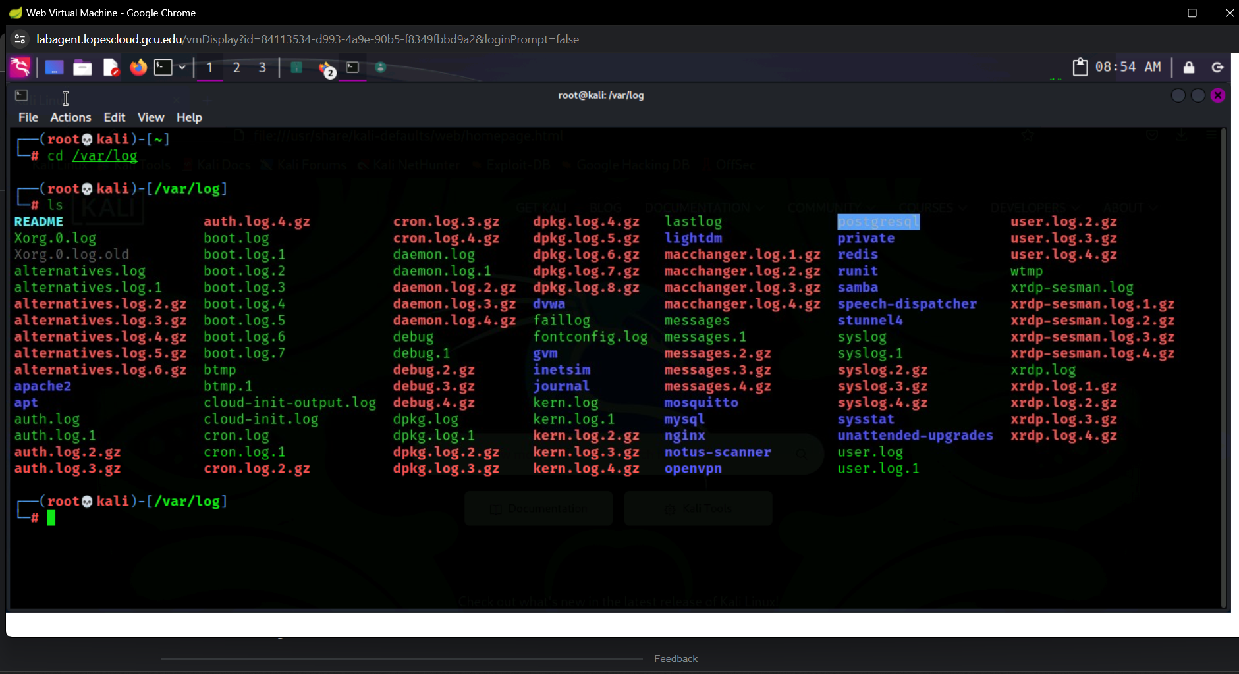

**I noticed syslog and wanted to view the various logs in that folder:**

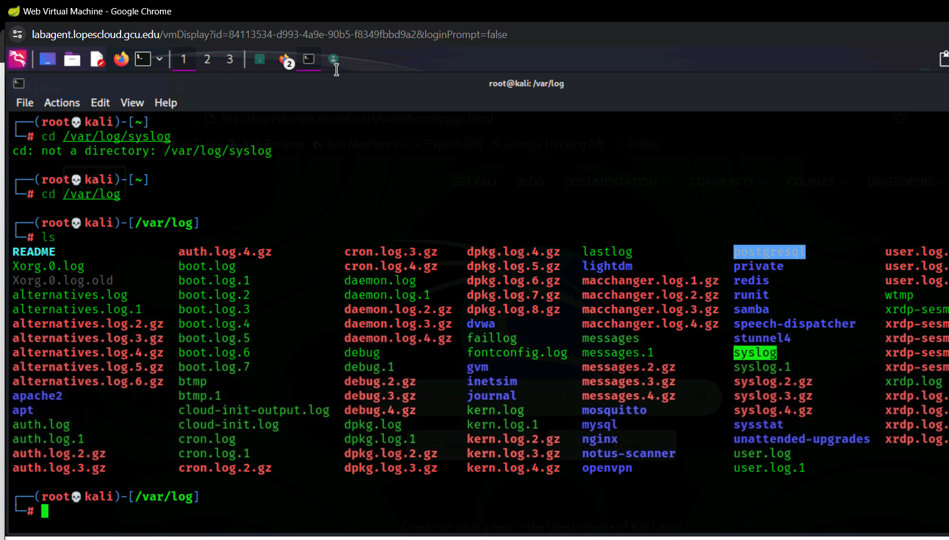

**Though it is not the most efficient way I used the command: less var/log/syslog which displayed all of the logs within the syslog file:**

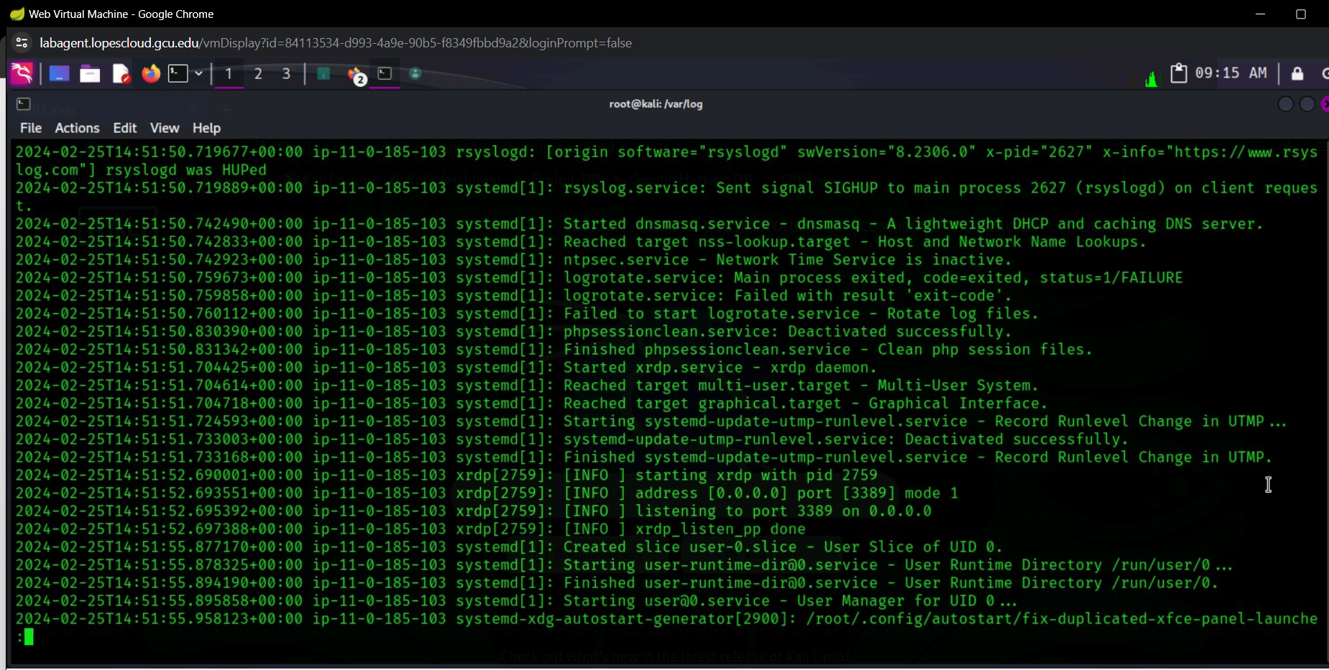

**One way that allowed me to sift through the logs faster was to determine what date these attacks were performed in order to get a better ballpark of what log to look for.**

**Learned that syslogs only keeps logs from that day’s or sessions activity. So onto the next type of log…**

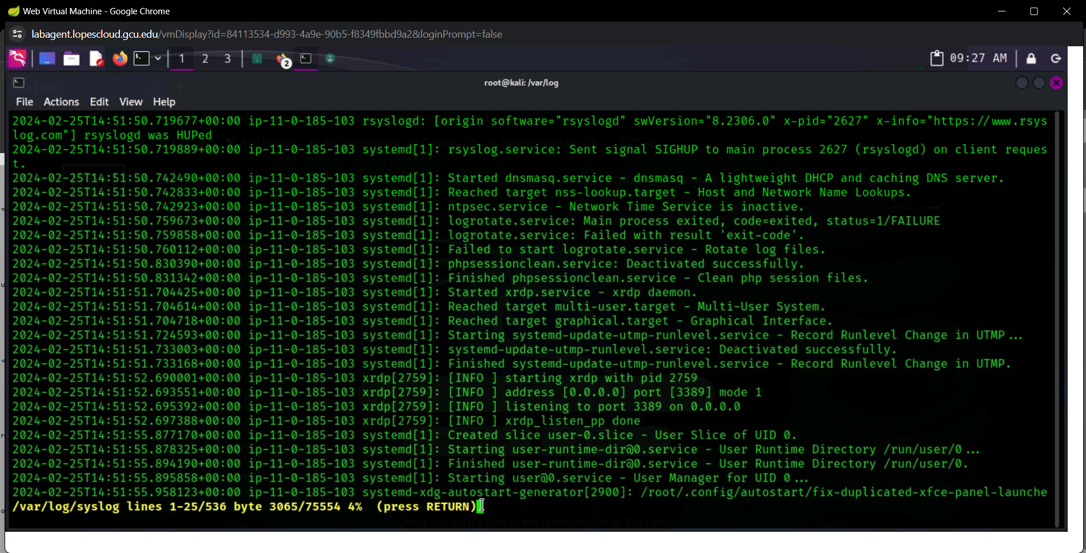

**I checked the auth.log but it was only from today’s session:** 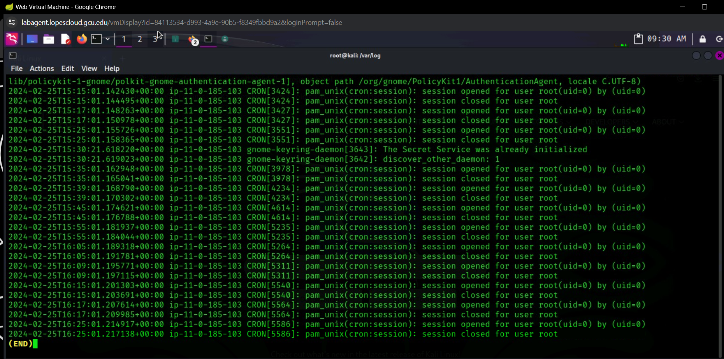

**I check user.log as well and doing it manually in the cmd seemed only show today’s sessions.**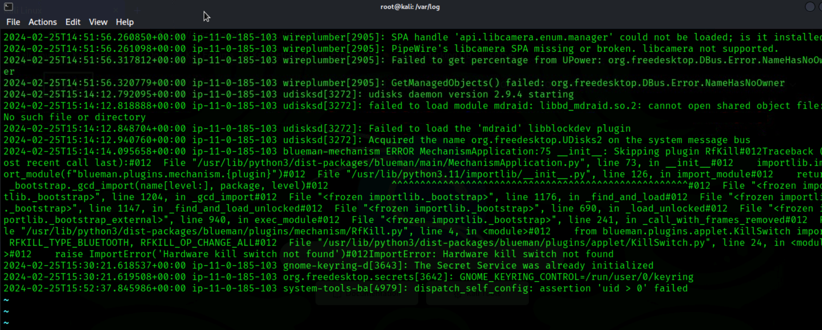

**I also checked xrdp-sesman.log:**

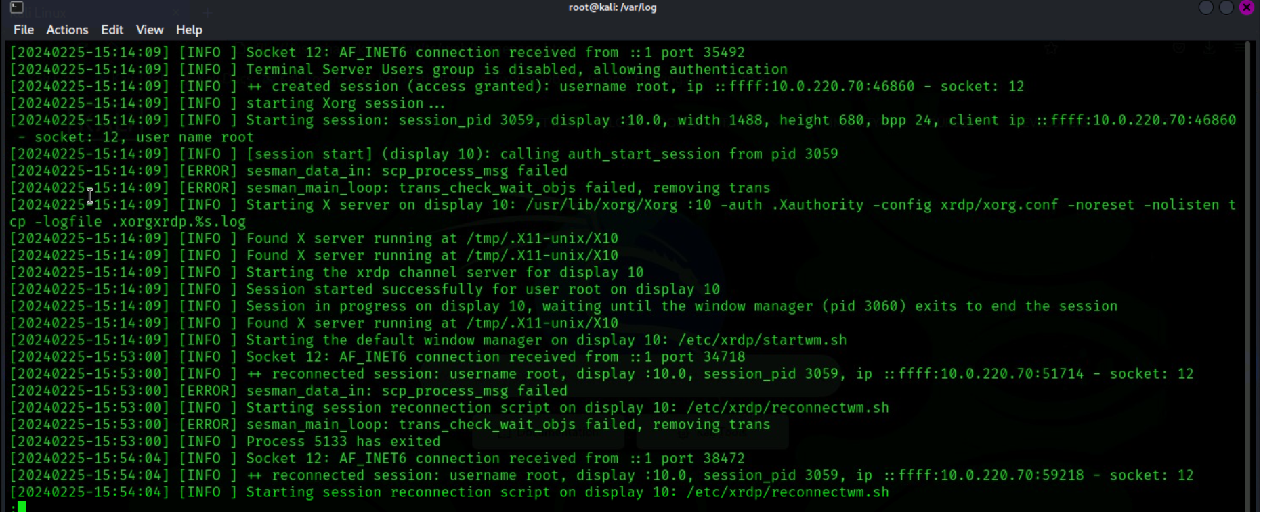

**Log check in this method is only helpful for daily checks or for quick skim the day of suspicious activity not for digital forensics trying to recover an incident that happened days ago or even the previous day so I tried to utilize a tool.**

**Decided to dig deeper into the gvm files as that is where I knew information about the VMs could be stored and it revealed more logs including OPENVAS.**

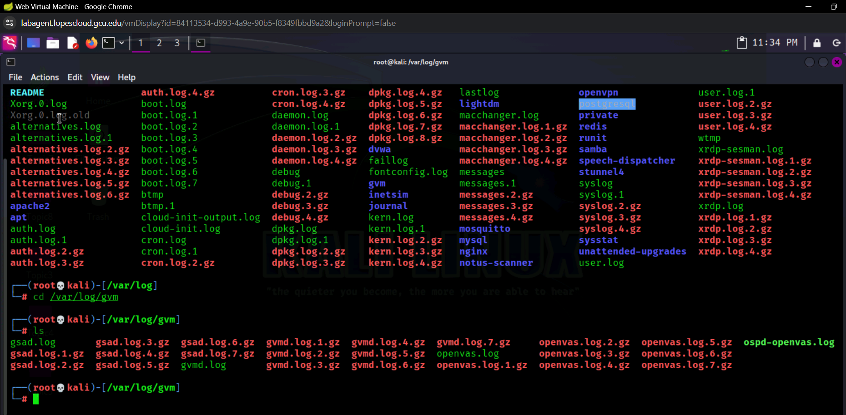

**Openvas log didn’t reveal anything,**

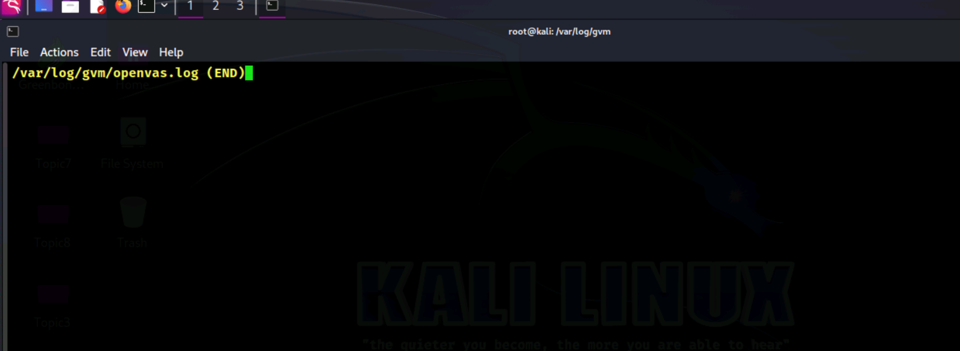

**Same outcome under gsad.log**

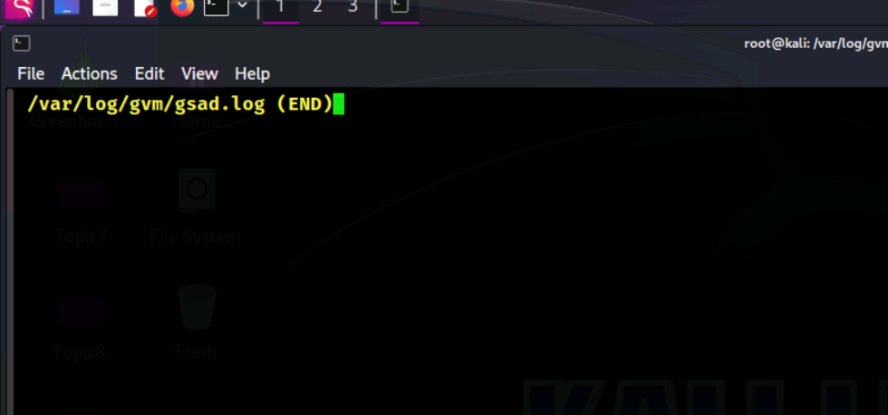

**Faillog didn’t provide me with much useful information:**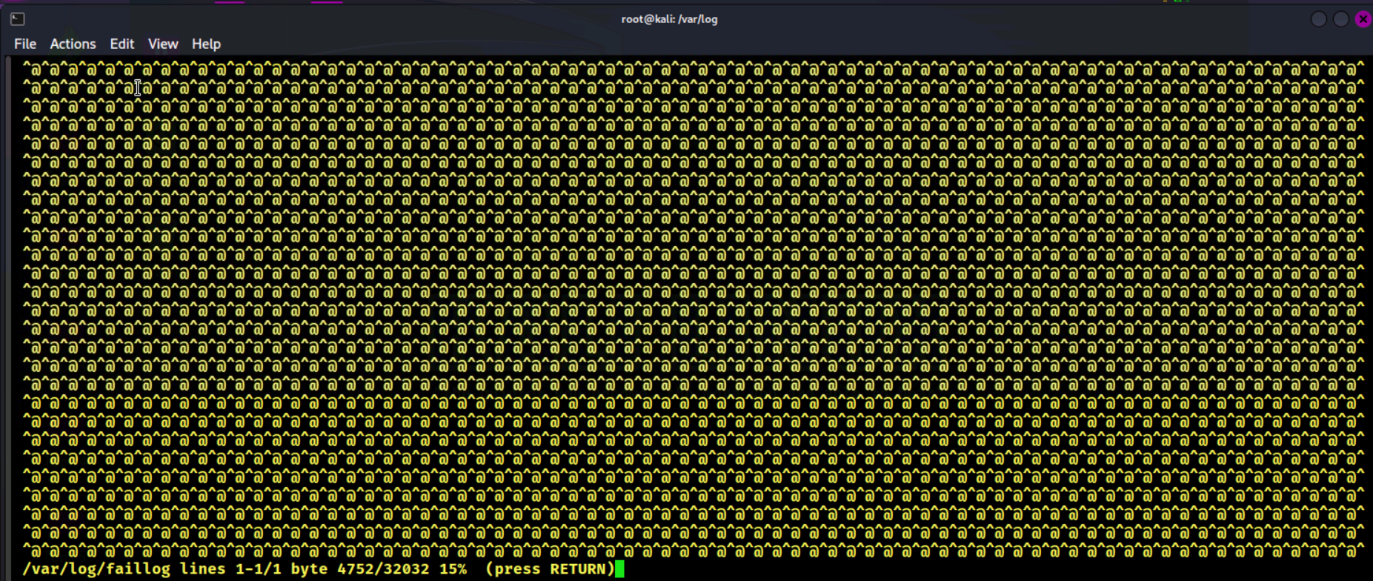

**Did find some older logs from the user login .1 section**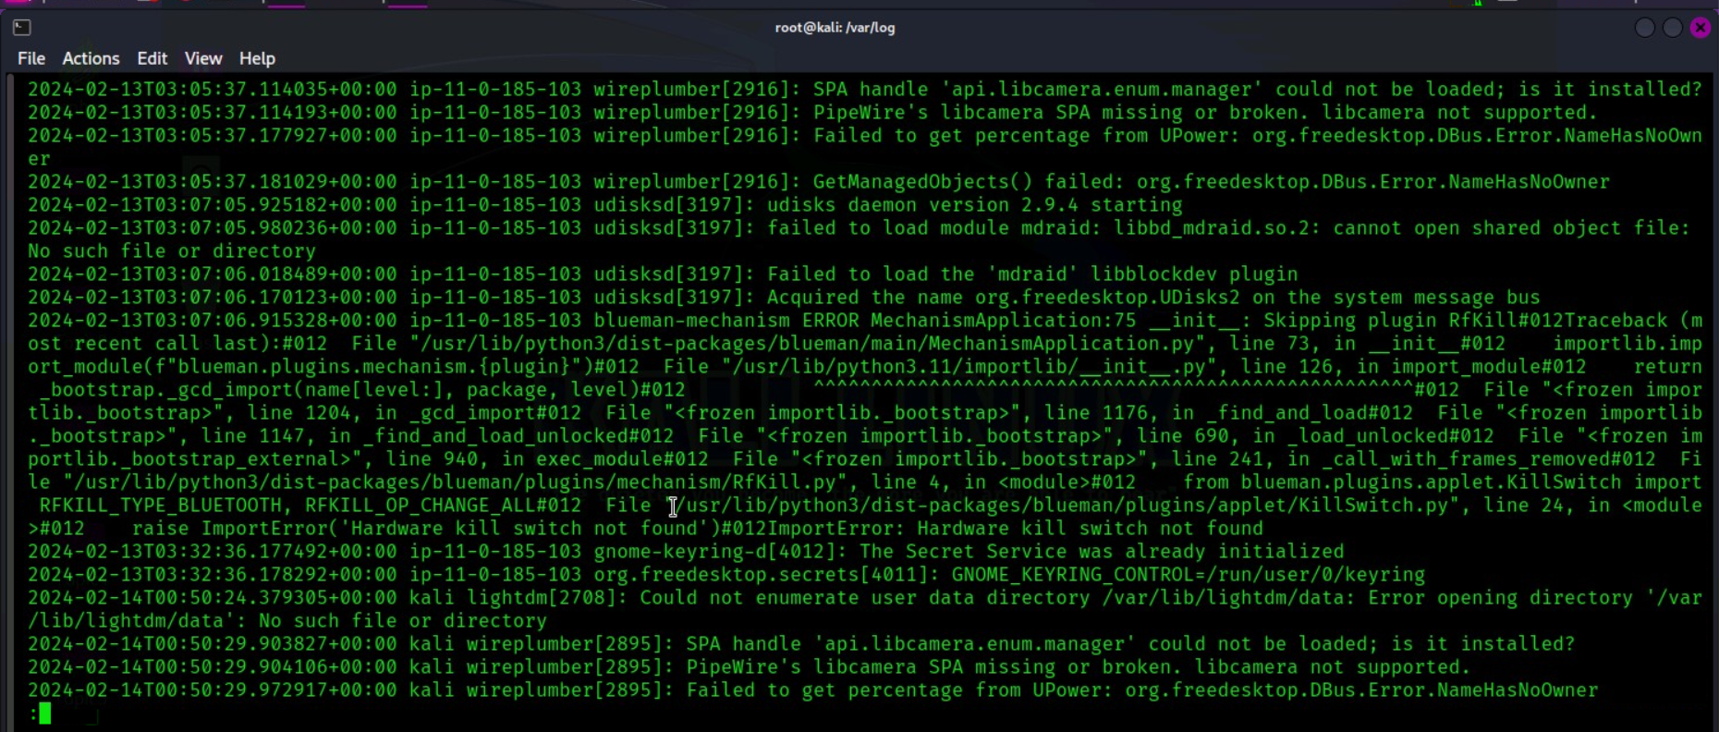

**Then wanted to try looking through the logs for postgresql files:**

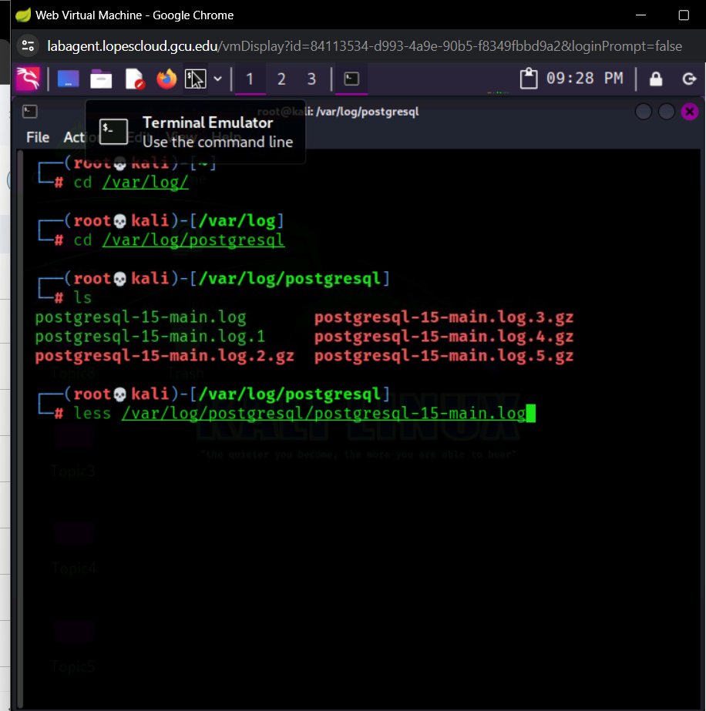

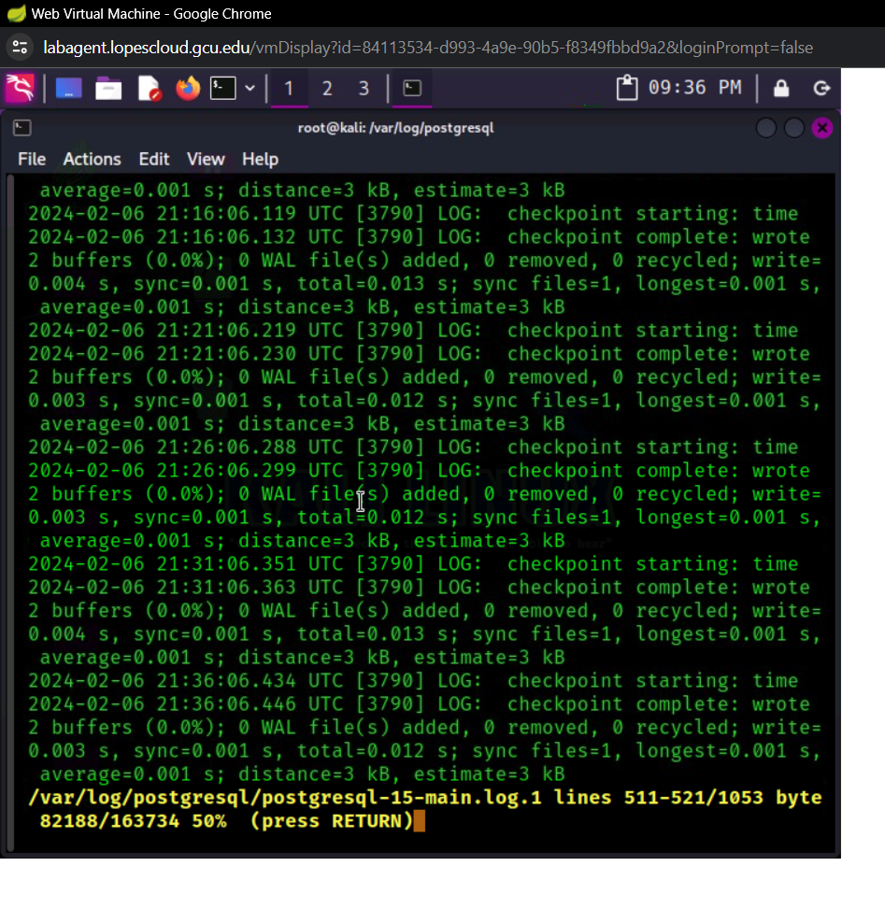

**Decided to utilize the winhex software to aid me in analysis.**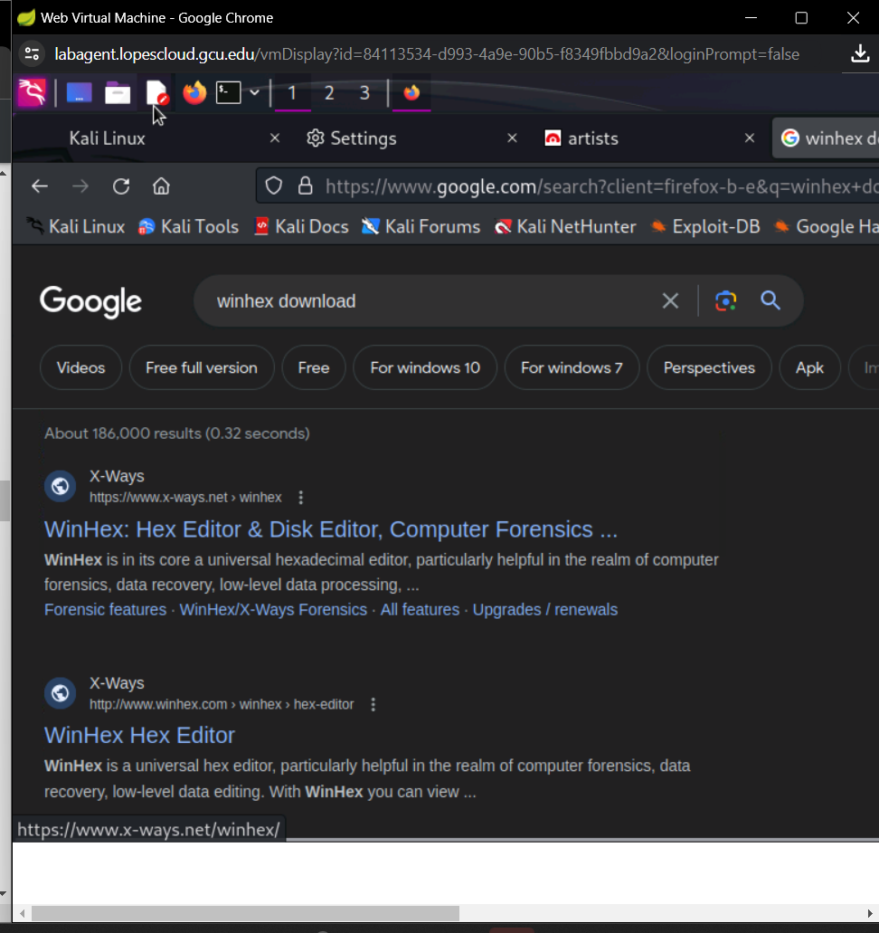

**Discovered that Winhex is just for windows OS so decided to research an alternative tool that is compatible with kali linux: Autopsy.**

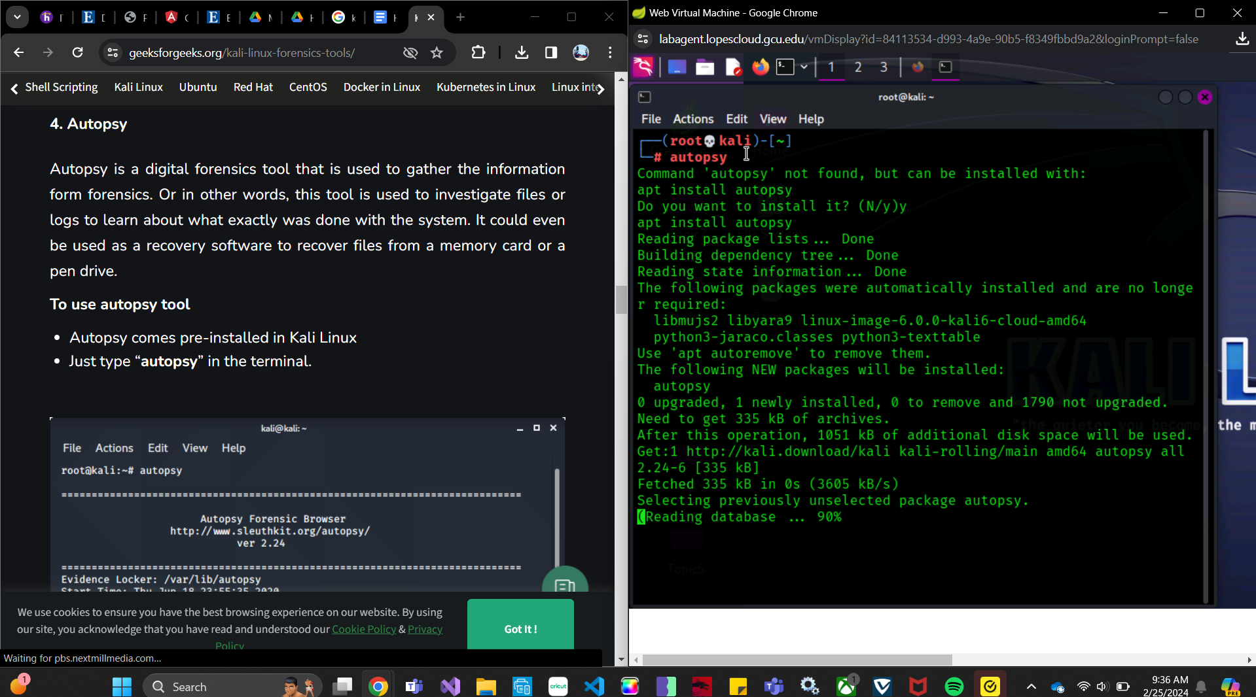

**Followed instructions:Once downloaded I wasn’t able to access much logging that had to deal with the VMs that were attacked. Since those logs were most likely inaccessible from the main host where the application was running.** 